Tessa Davis

22 Feb 2022

Foundations of Programming (Python)

Assignment 05

Module 05 Knowledge Document

**Assignment**

A theme of this week seems to be starting to think about the best way to write code rather than just accepting code that will “get the job done.” Understanding that there still may be multiple versions of good code, the increasing emphasis seems to be on ways to optimize scripts and organize your work in anticipation of working witht other coders . We also introduced writing to memory from a file, dictionaries, structured error handling, and Github.

**Discussion**

Lab 05-A

Using some print statements as I developed the code here was incredibly helpful for troubleshooting the formatting issues. I was particularly giddy when I realized I could solve the trailing comma issue in the ‘write’ option by printing everything up to [:-2]. It had to be -2, I realized, because -1 was actually the space I put in after the comma. It is almost funny how something so small can vex you for so long! The troubleshooting on this lab went faster than previous exercises and I did more detailed commenting on what given lines of the code accomplished.

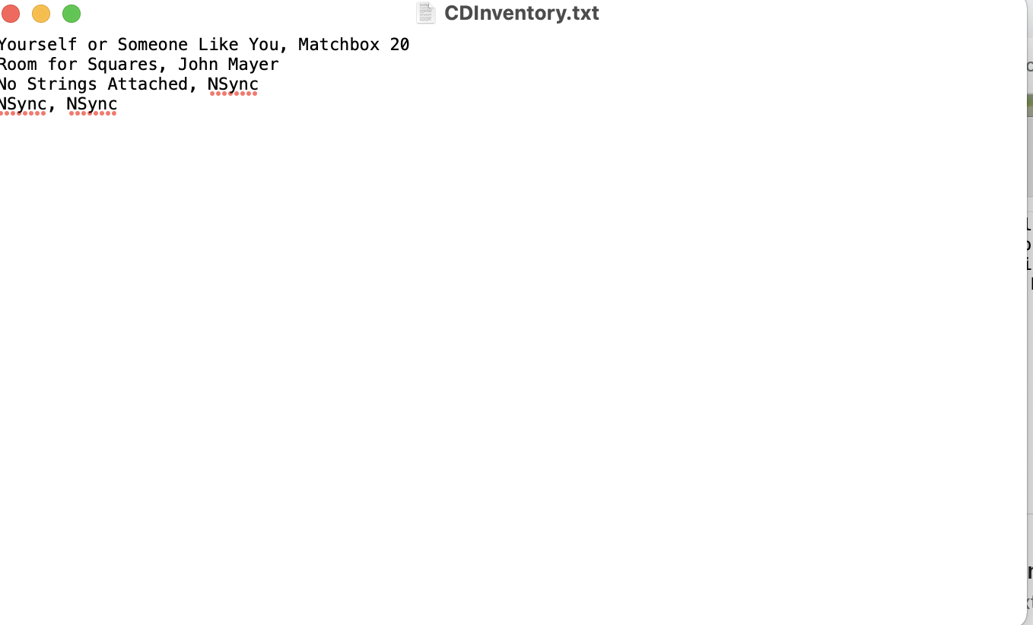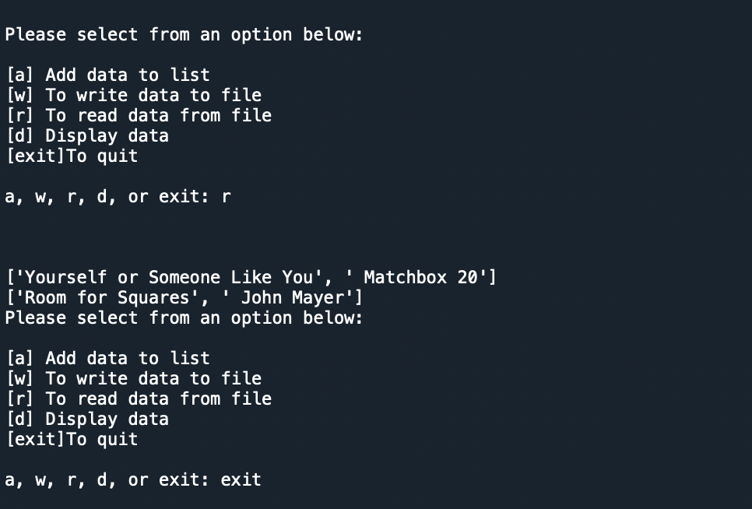

Figure Successful Write to File Lab 05-A. Figure Successful Read to Memory Lab 05-A

The structure of the while loop with the if and elif statements allows the user to loop through all but exit as many times as she would choose. The input data option is fairly straightforward in requesting user input, converting it to a list and then appending the list to the 2d lstTbl. The w option requires a bit more work with formatting the data to display neatly in the txt file. The ‘r’ option opens the .txt. file, then reads and turns each row therein into a list to be printed in memory. Lastly, the ‘d’ option displays the data from the current run of the file as rows drawn from the 2d list.

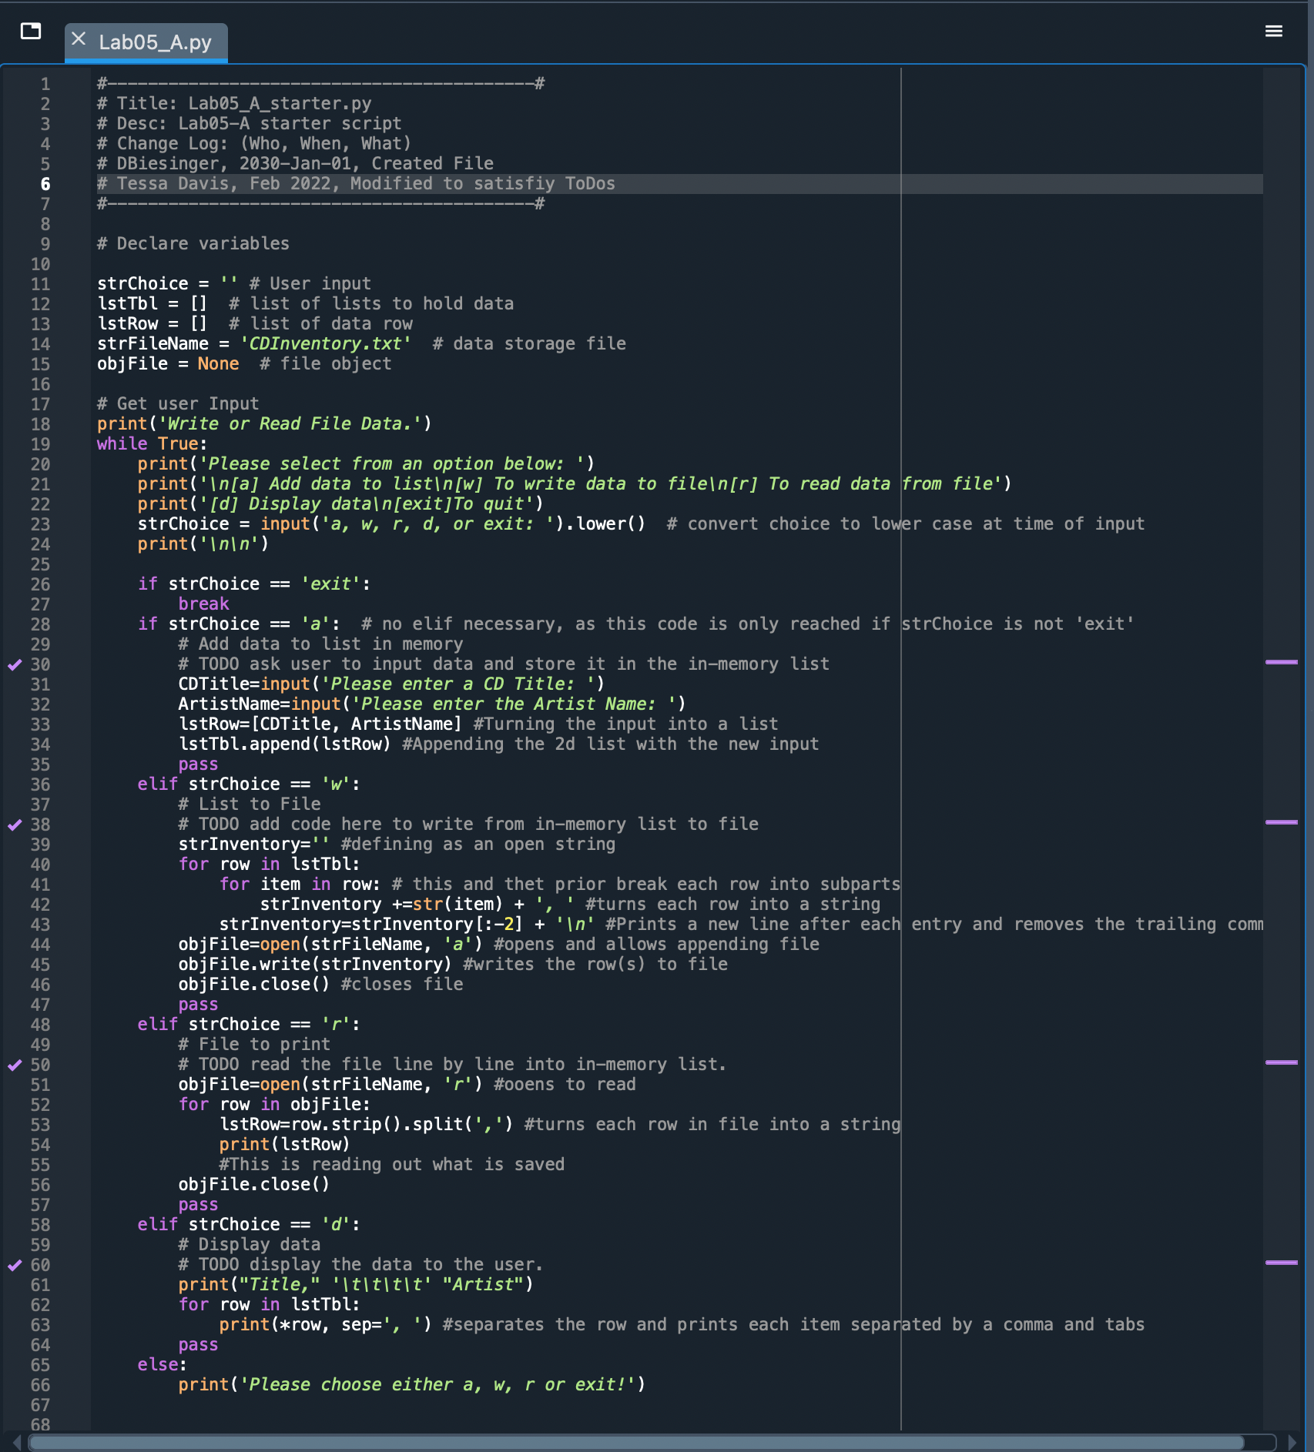

Figure Lab 05-A Code Script

Lab 05-B

I struggled a lot with one issue on this one. I initially created the dictionary with direct dictionary input, rather than string input then converted to dictionary. The result was that prior entries were overwritten. I functionally understand what happened but am not clear on why the append command works differently with dictionaries as the rows than it seemed to with the lists. I imagine there is a way around this but I was not able to figure it out. The next problems I ran into were in reading and displaying the data. I repeatedly got the error shown in Figure 04. Ultimately, I think it came from a space getting into the .txt file from when I manually cleared it out afer running different iterations of the code. I also could not get nested for loops to work to extract the values out of the rows in the ‘d’ script. I understand that * is efficient but wanted to show myself that there was another way. Ultimately, I used the * operator taught in the lessons but am not entirely clear on what its for loop equivalent is.

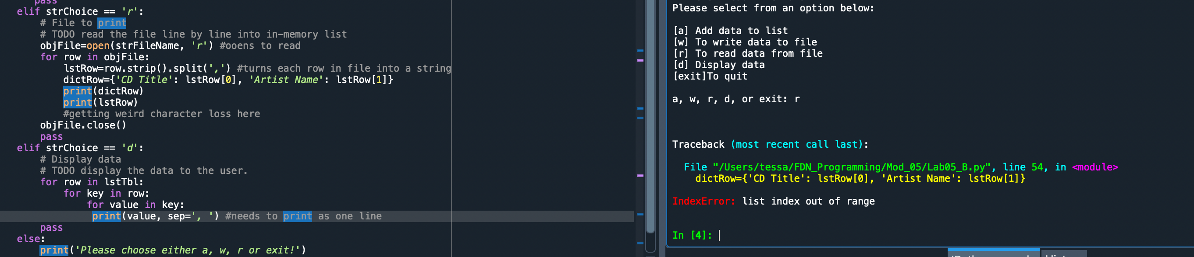

Figure R Index Error

The script I came to through many iterations is shown in figure 05 and the .txt file in figure 06. I commented more heavily on this one than previous assignments.

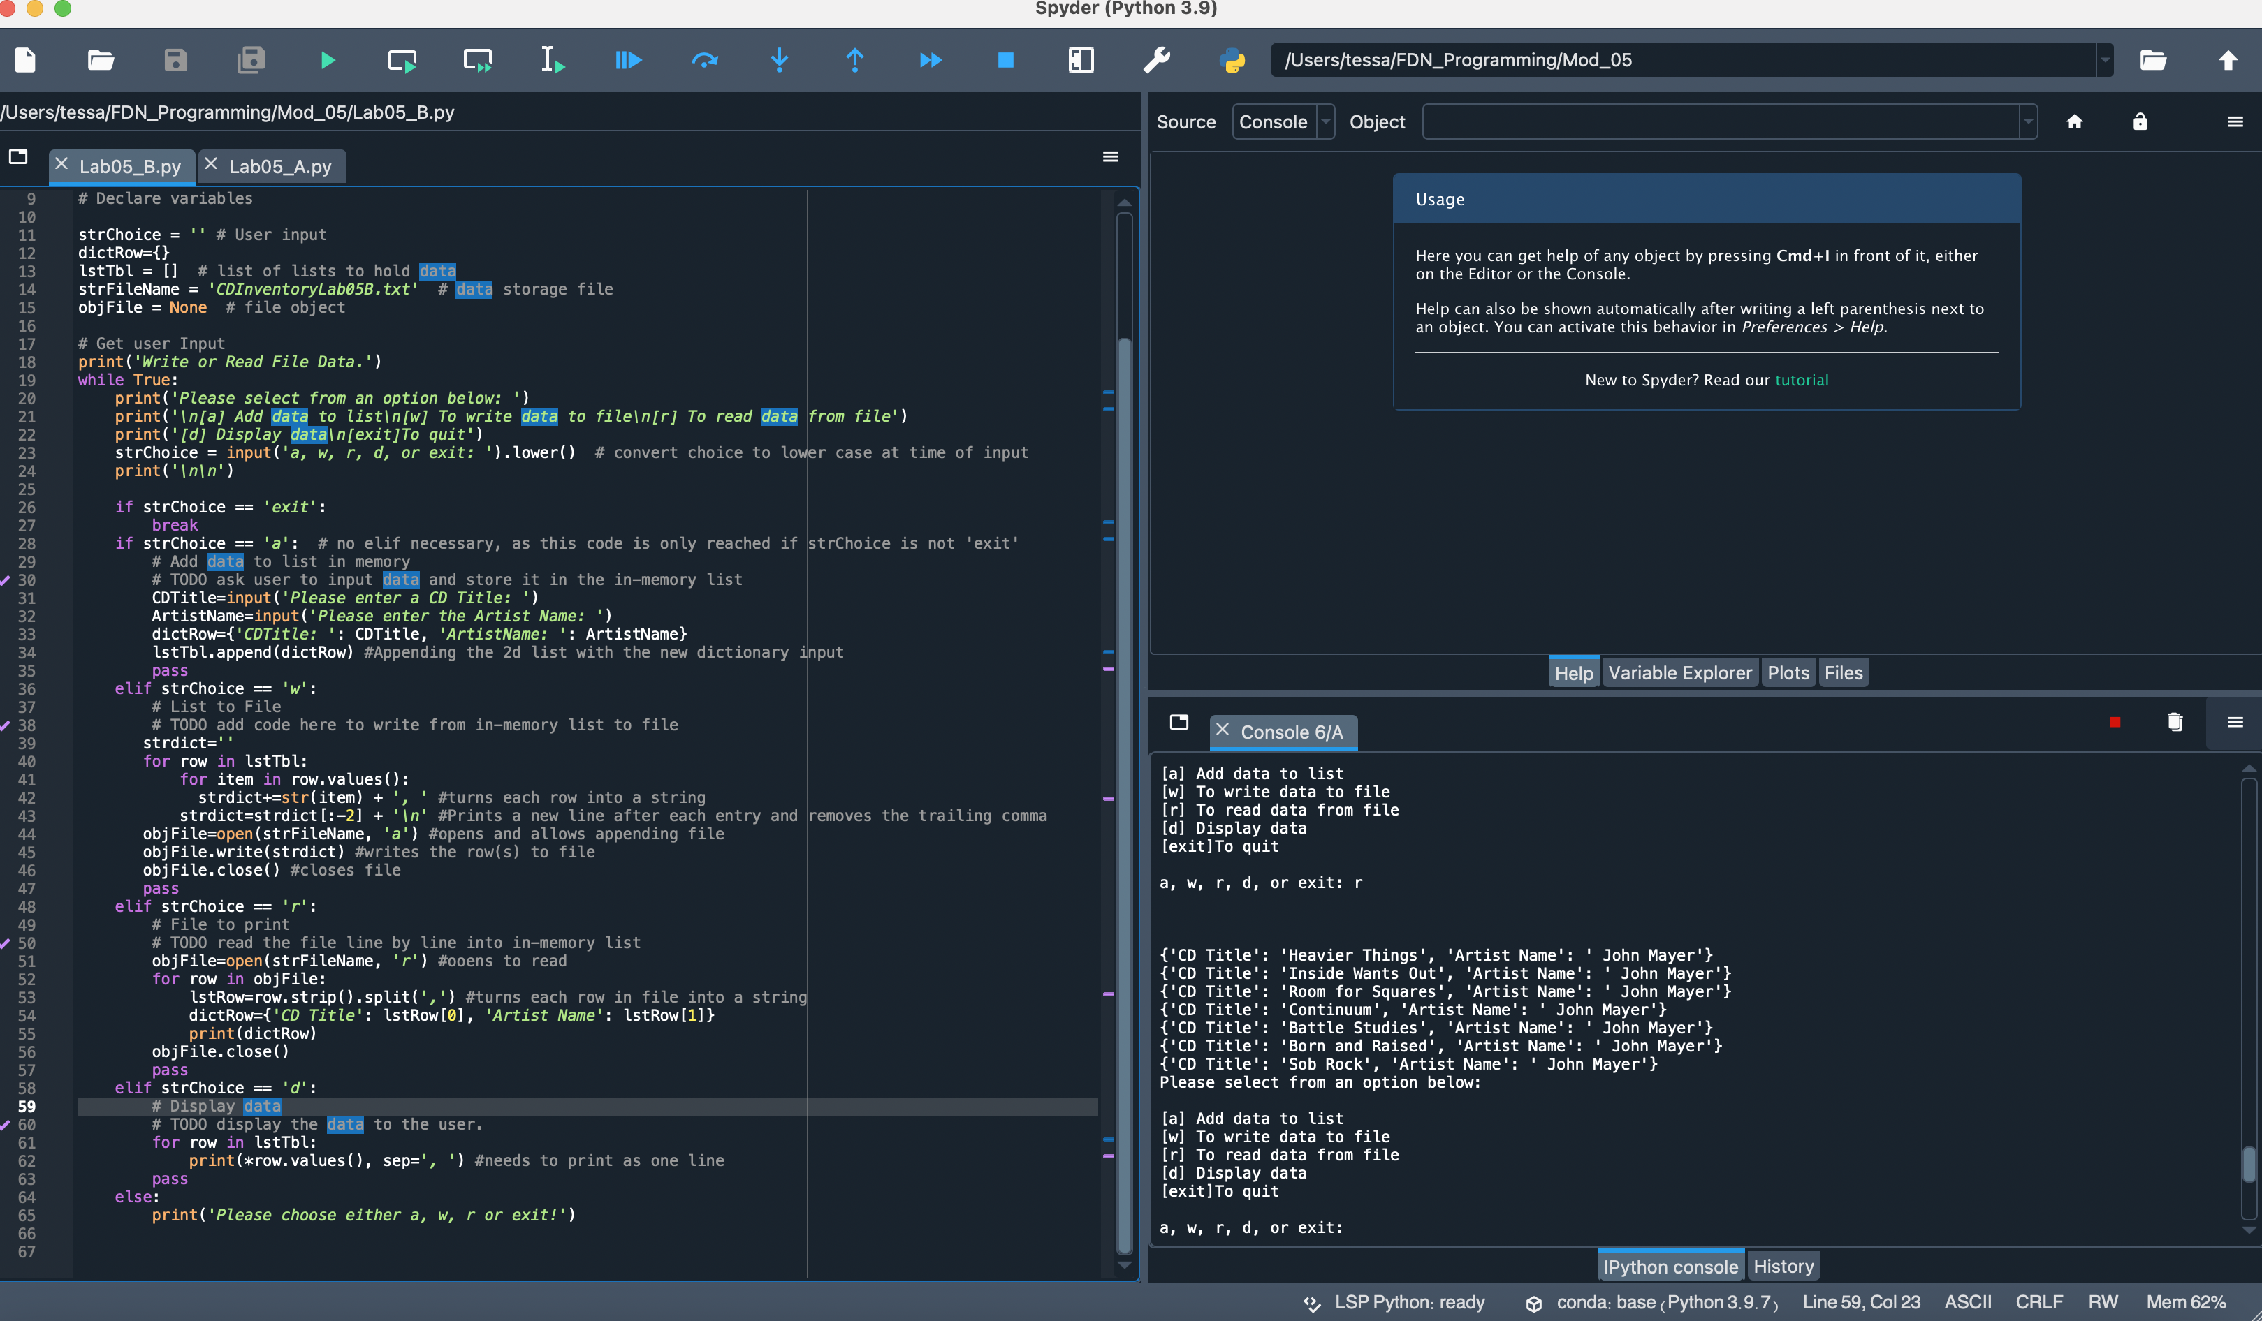

Figure Lab05-B Script

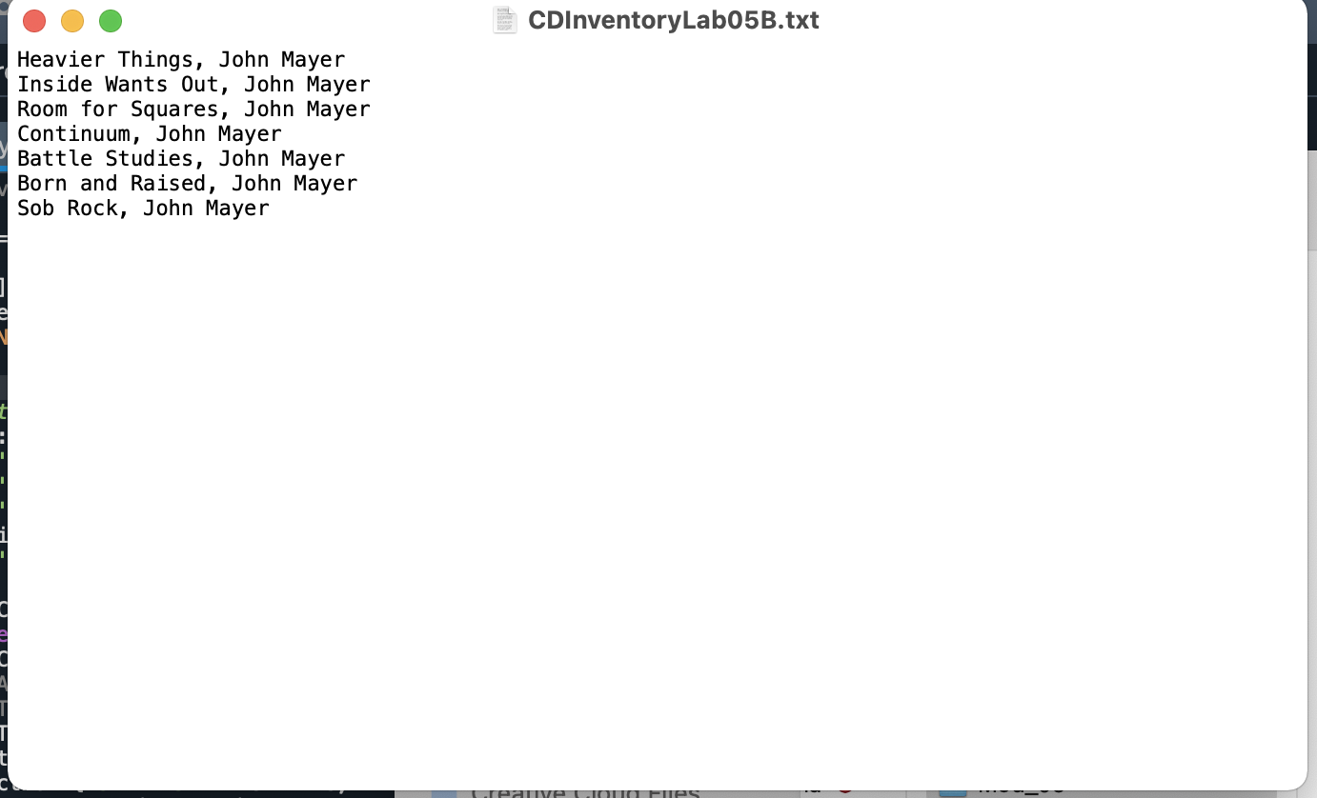

Figure Lab05-B .txt file

Regarding improving the scripts output, the main critique would be readability of simply displaying the data as dictionary rows. It is a bit busy. You could improve it by further breaking down the data to display just the values, rather than the values as keys using code similar to that in the w block that converts the data to a string before printing.

Functions and Template

Creating template preferences was intuitive. Functions are also somewhat familiar from the basic text mining I had done prior to enrolling in the course. Looking forward to learning more about them in module 06 as they seem to streamline code.

Separation of Functions and Structured Error Handling

These two topics see conceptually connected in the sense that they both go to functionality, though at different stages. Separation of functions seems to aid development and troubleshooting, supporting functionality while in the drafting process. Structured error handling works at the level of when running the code to prevent errors that crash the script.

Github

All set up here. It actually appears I can get some greater functionality as a faculty member, so I am going through the process of verifying my faculty status.

CDInventory Modifications

The time put in on Lab05B made much of the assignment reasonably straightforward. The new code used was the get() method within a for loop to find and delete the user input for the desired ID Number to delete the entry. There was one issue that I was not sure how to resolve regarding duplicated entries (I recall some discussion of duplicated entries being a problem now that we will learn to tackle later). In my delete block, I used code to read the existing data in so the user could identify which entry she aimed to delete. I then changed the write function to ‘w’ to overwrite the existing entries in the .txt so the file would reflect the new table. I discovered that, depending on the ordering of operations the user selected, duplicate entries could be created that would get saved into the text file. I believe this is because other entries get loaded into memory (and thus duplicated in the table). So while I was able to create a useable delete block, some duplication of entries could occur. You can see this most clearly in Figure 12 where entry 7 was deleted from the table but appears in duplicate (alongside entry 6—the other entry added in that kernel) at the top of the table.

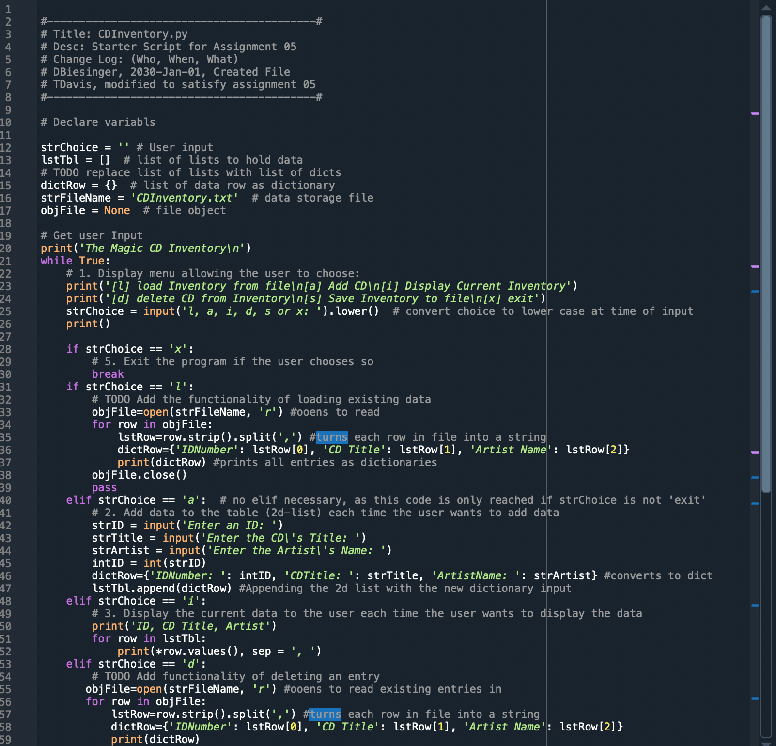

Figure CDInventory Modified Code 1

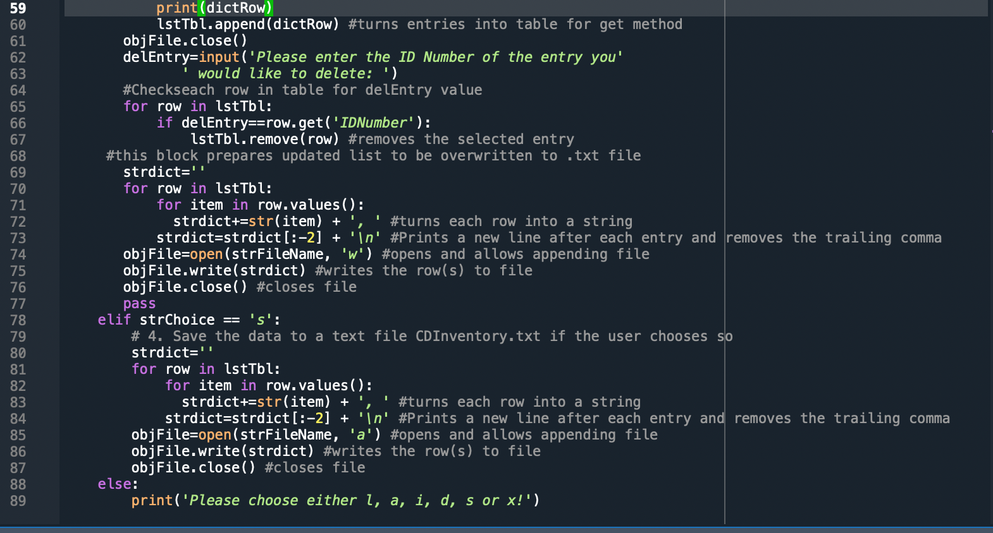

Figure CD Inventory Modified Code 2 of 2

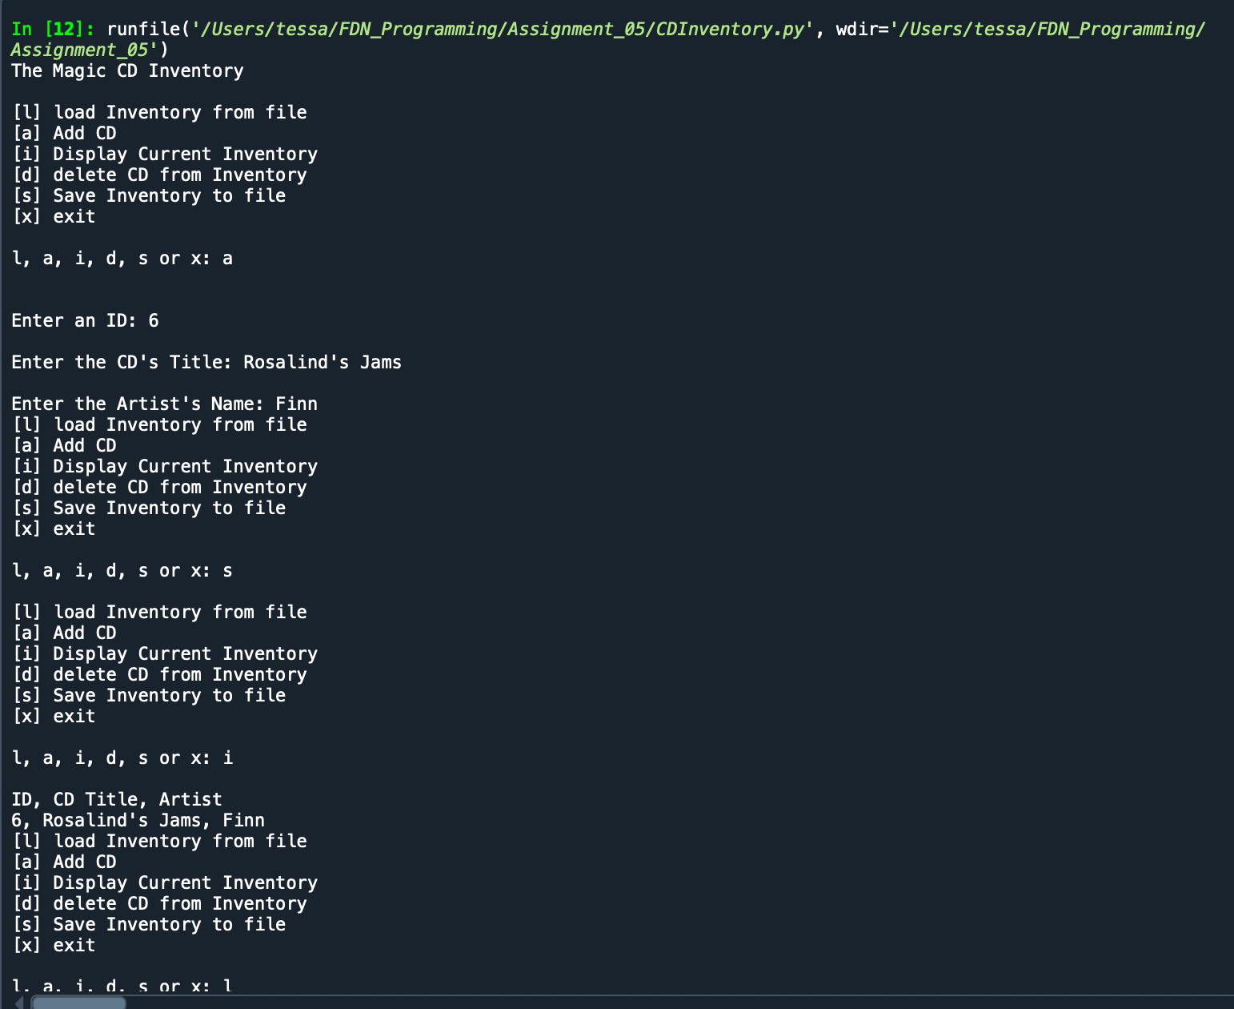

Figure Successful Spyder Run 1 of 2

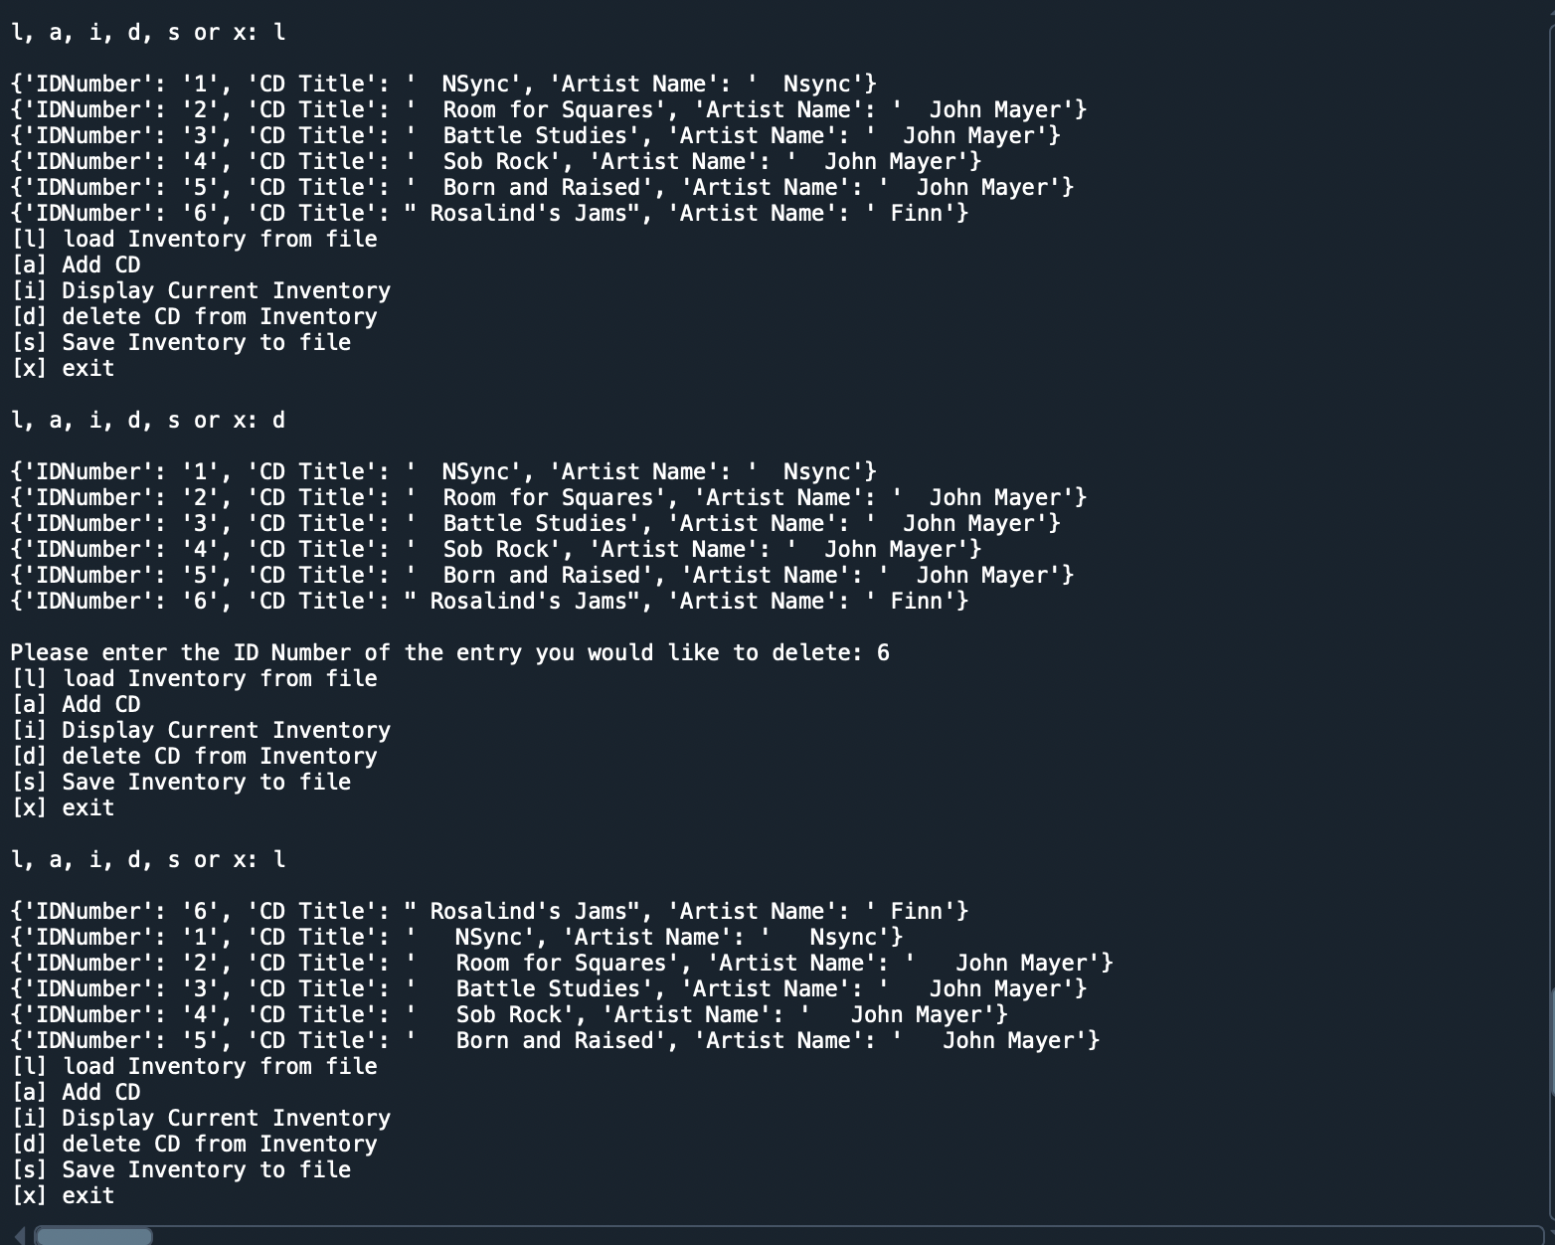

Figure Successful Spyder Run 2 of 2

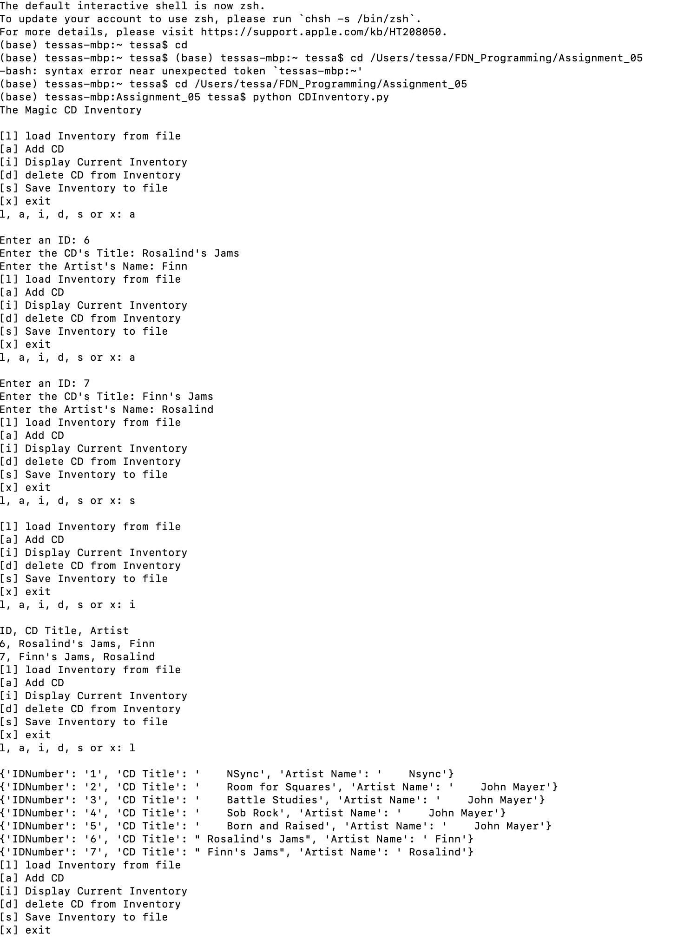

Figure Terminal Run 1 of 2

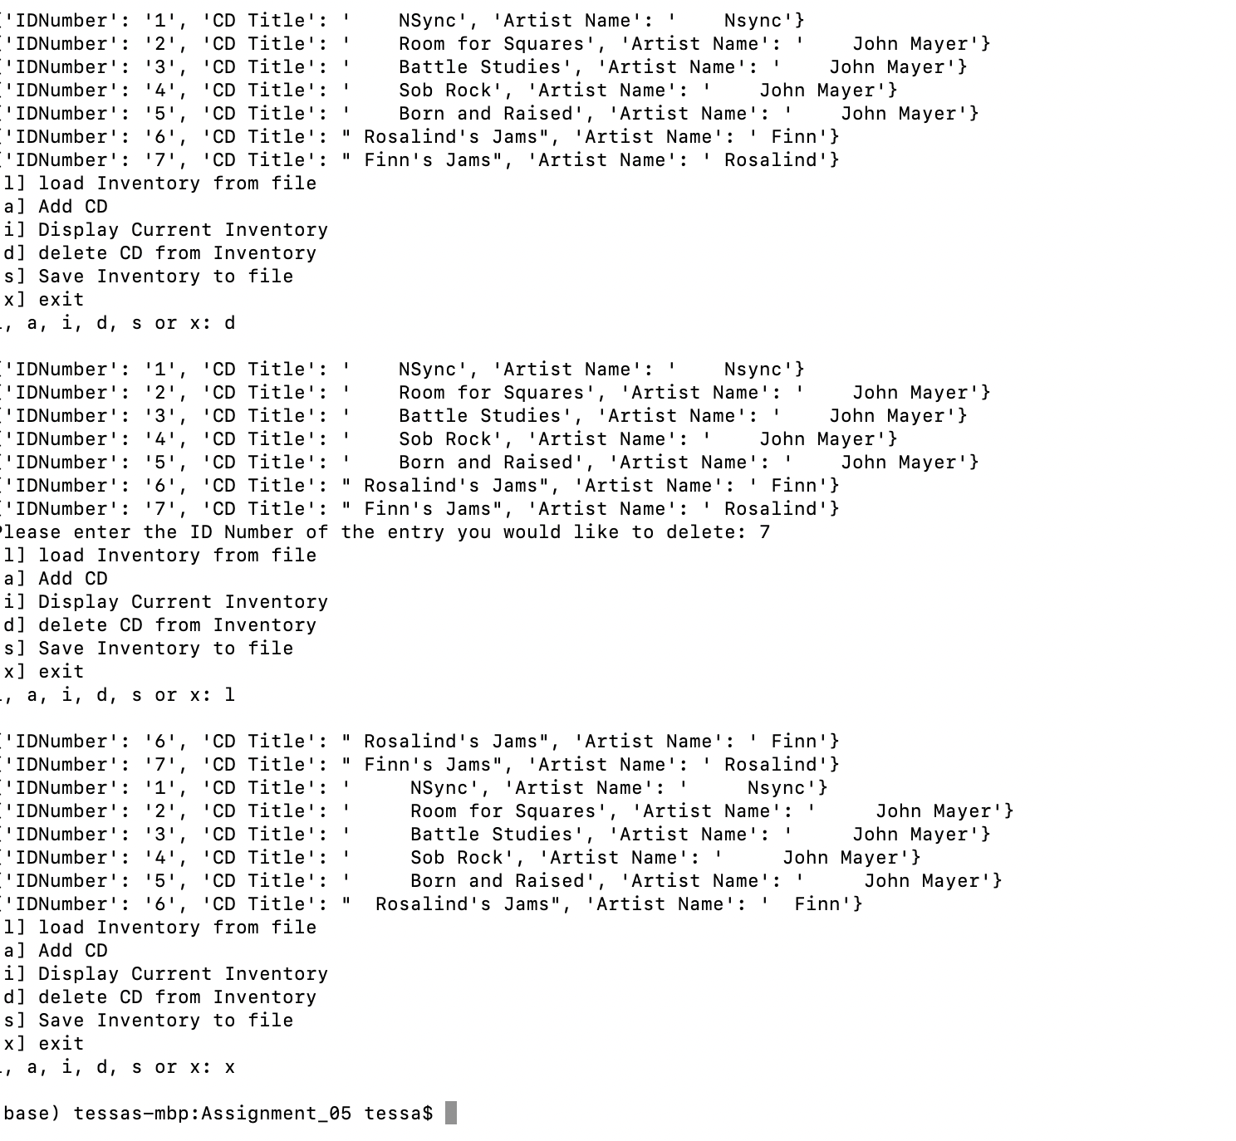

Figure Terminal Run 2 of 2

**Conclusion**

This week was an interesting mix of relative success and frustration. I know that I am getting faster at troubleshooting. I also am increasingly able to articulate what needs to get done and the logical ordering of steps. I still struggle, in part, at least with getting the proper syntax as only the most basic stuff has become second nature (e.g. print() or input()). The new aspects of this week, such as dictionaries and more methods, are reasonably comfortable as concepts but I am still struggling to see the forest for the trees (i.e. in which scenarios you might prefer to use a dictionary over a list).